Forecast Growing Expenses Due to Inflation - Full Answer
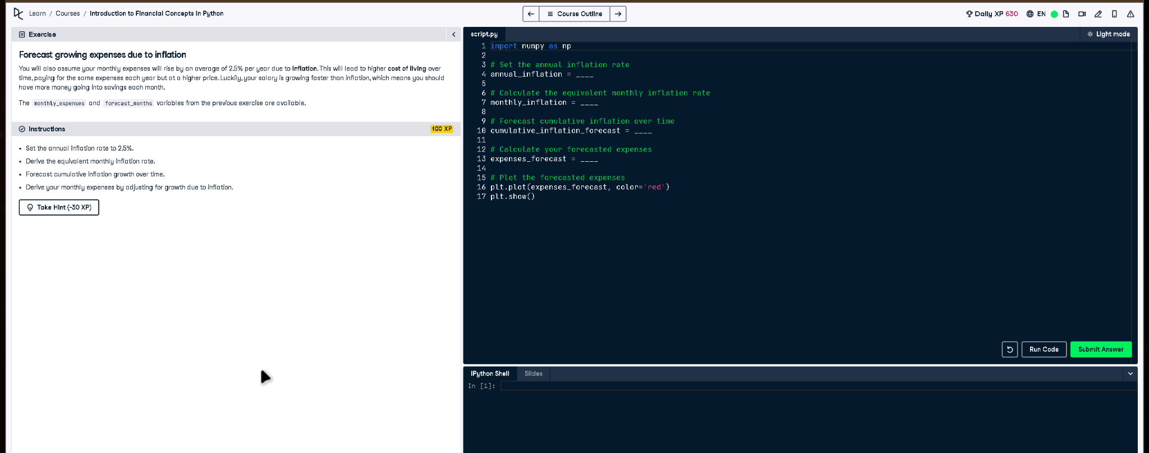

Full Code Answer:
import numpy as np
# Set the annual inflation rate
annual_inflation = 0.025
# Calculate the equivalent monthly inflation rate
monthly_inflation = (1 + annual_inflation)**(1/12) - 1
# Forecast cumulative inflation over time
cumulative_inflation_forecast = np.cumprod(np.repeat(1 + monthly_inflation, forecast_months))
# Calculate your forecasted expenses
expenses_forecast = monthly_expenses * cumulative_inflation_forecast
# Plot the forecasted expenses
plt.plot(expenses_forecast, color='red')
plt.show()

Question:
How can you forecast monthly expenses over time accounting for a 2.5% annual inflation rate?

20-word Explanation (Question):
Forecasting inflation involves converting annual rates to monthly equivalents, enabling cumulative projections of rising expenses over long periods.

Answer:
Convert the annual inflation rate to a monthly rate, use np.cumprod for cumulative growth, and multiply by expenses.

20-word Explanation (Answer):
Using np.cumprod on monthly inflation factors yields a cumulative inflation forecast, which adjusts monthly expenses for realistic cost increases.

